CS462 Final Submission

Introduction
Departed Affairs & Co is meant to be a roguelite action game set in the early 1900's. The main character the player controls is Dr. Vibble, a traveling spiritualist who gets paid from the living to travel to the spirit world and deal with the dead. Each job entails a unique procedurally generated map filled with multiple enemies, hazards, story encounters, as well as upgrades. Overall, the goal of the game is to explore the map, fight harder and harder enemies including bosses, to eventually get enough upgrades to beat the final boss.
Our game is made of two parts, the overworld, as well as the underworld. The overworld, representing the living world, is the player's main hub. Here the player can visit shops, get supplies, obtain upgrades, and relax in between play throughs. Along with this, the player can manage their progress, equipment, and reputation before they head into new battles. From here the player can then go to the cemetery. The Cemetery acts as the level selector, once the player obtains an assignment, they can go to the graveyard to see their active jobs. To choose a job, the player can visit different grave stones, marked with candles and offerings, which represent active jobs. Once you choose a grave the mission starts. From here on out the player is transported to the underworld to try and contact the spirit tied to that grave site.
The Underworld is where the game mainly takes place. Here the player's goal, as stated, is to fight through enemies to try and contact the spirit tied to the assignment. In each level there are 9 to 12 rooms connected by shifting paths. Each of these rooms are procedurally generated with randomly spawning enemies. The enemies in this case are hostile spirits born from trauma and unrest. Along with this, friendly spirits can be found throughout the rooms that can offer rewards to the player for saving them as well as side quests that can be completed for a better reward. Occasionally, the player can also find boss encounters. Bosses, unlike the enemies, are corrupted forms of the target spirit. Thus, these bosses are much more powerful and have custom moves compared to the other normal enemies. Once a player completes an assignment, they can go back to the overworld to collect their reward.

Technical Details

Content Loading Pipeline

Manifest, Storage Roots, and Cache Layers

Manifest-driven project layout
The engine reads and writes a single manifest.json file instead of baking content into the build. At startup it makes sure the expected folders under project/SRC exist so assets, loading screens, and shared content can be found without extra setup.

Storage roots and regenerated caches
Human-made files live in SRC/assets and in the manifest. When the game starts it picks a content folder for the current map (content/<map> by default) and reads ready-to-run files from there. Prebuilt textures and light maps live in cache/ so the renderer can reuse them instead of reprocessing images every launch. asset_tool.py and light_tool.py rebuild the cache when the manifest flags a change, and the rebuild queue runs these tools before the game begins.

Asset Library and Texture Pooling

AssetInfo metadata and shared caching
The AssetLibrary keeps the manifest and the SRC/assets folders in sync. It builds AssetInfo records that describe animations, lights, spawn rules, and texture paths. Assets use this shared data so new spawns do not keep rereading JSON. Once rendering is ready, the library or the map loader preloads animation variants so GPU-ready frames are available before assets enter the world grid.

Python-powered texture pipelines
asset_tool.py reads the manifest, looks at source frames in SRC/assets/<asset>, scales them to the needed sizes, applies simple effects, and writes ready PNGs into cache/<asset>. light_tool.py rebuilds light masks when the manifest marks them stale. Because these tools follow the manifest, the game only reads prepared files and never spends frame time on heavy image work.

Map, Room, and Trail Construction

Manifest map layers, rooms, and trails
Each map entry in the manifest lists layers, room data, trails, boundaries, assets, and grid settings. The loader reads these values, figures out map size, and fills in spawn controls. If required layers are missing it creates a simple fallback room so there is always somewhere to play.

Room geometry, spawn groups, and trails
The room generator turns layer data into rooms with shapes, spawn groups, and rules on how children inherit properties. The spawn planner samples rooms and trails, respects spacing filters, and creates assets that are finalized once placed. Trails use the same system but rely on path-shaped areas to control where things appear.

Grid settings and caching
Map grid settings define resolution and chunk sizes. The loader uses them to build the world grid and to set how assets handle collision, depth sorting, and camera culling so the layout stays consistent across rooms.

Scene & Asset Structure

World Grid, Chunks, and Rooms
The world grid keeps assets in chunks and points so collision and visibility checks stay fast. Chunks appear when needed and assets register themselves at exact points. The active set only covers what the camera can see.

Asset metadata, child assets, and tiling
Each asset carries shared info, a spawn id, animation state, and optional tiling data. The shared info lists lights, shadows, child assets, and spawn groups. Child assets attach through animation timelines, and tiling lets a single asset repeat across a larger area without creating many copies.

Animation runtime and custom controllers
The animation runtime advances frames, moves assets, and works with controllers. The update layer offers helpers for pathing, movement, and animation changes. Controllers can be built-in or custom and are picked by a key set in the manifest.

Runtime Flow & Rendering

Main loop, input, and asset updates
The main loop runs around 60 frames per second. It reads input, forwards events to assets and the player controller, then updates each asset. Updates run controller logic, advance animations, and flag render data when visuals or lighting change. During setup the app also starts audio and drops into Dev Mode if no player asset is present.

Screen grid, camera, and lighting
The warped screen grid keeps the camera aligned with the map and smooths zoom and pan. It rebuilds itself from the world grid each frame so the map-to-screen link stays correct. Camera details and lighting toggles feed both gameplay and Dev Mode. Light updates flow through the light map tools that serve the renderer and editor panels.

Rendering pipeline and composite packages
The scene renderer clears the screen, draws background layers, and asks the composite renderer to assemble each asset's render package. Packages collect textures, child attachments, and lighting in the right order. Afterward the renderer sorts by depth, draws lighting, and adds depth cues, dark masks, and any post effects.

Auxiliary runtime systems
Beyond rendering, the Assets module tracks selection, saves map info changes, and serves the editor panels. Hidden or distant assets can be skipped to save work. The rebuild queue waits for asset and light tools to finish before the main loop so Dev Mode edits stay safe.

Dev Mode Toolkit
Dev Mode turns the engine into an editor. It favors responsiveness over visual polish and saves edits back to the manifest. Open it with Ctrl+D or by loading a map without a player asset. Layout preferences live in dev_mode_settings.json, and changes flow into the shared asset library.

Workspace & navigation

Main screen
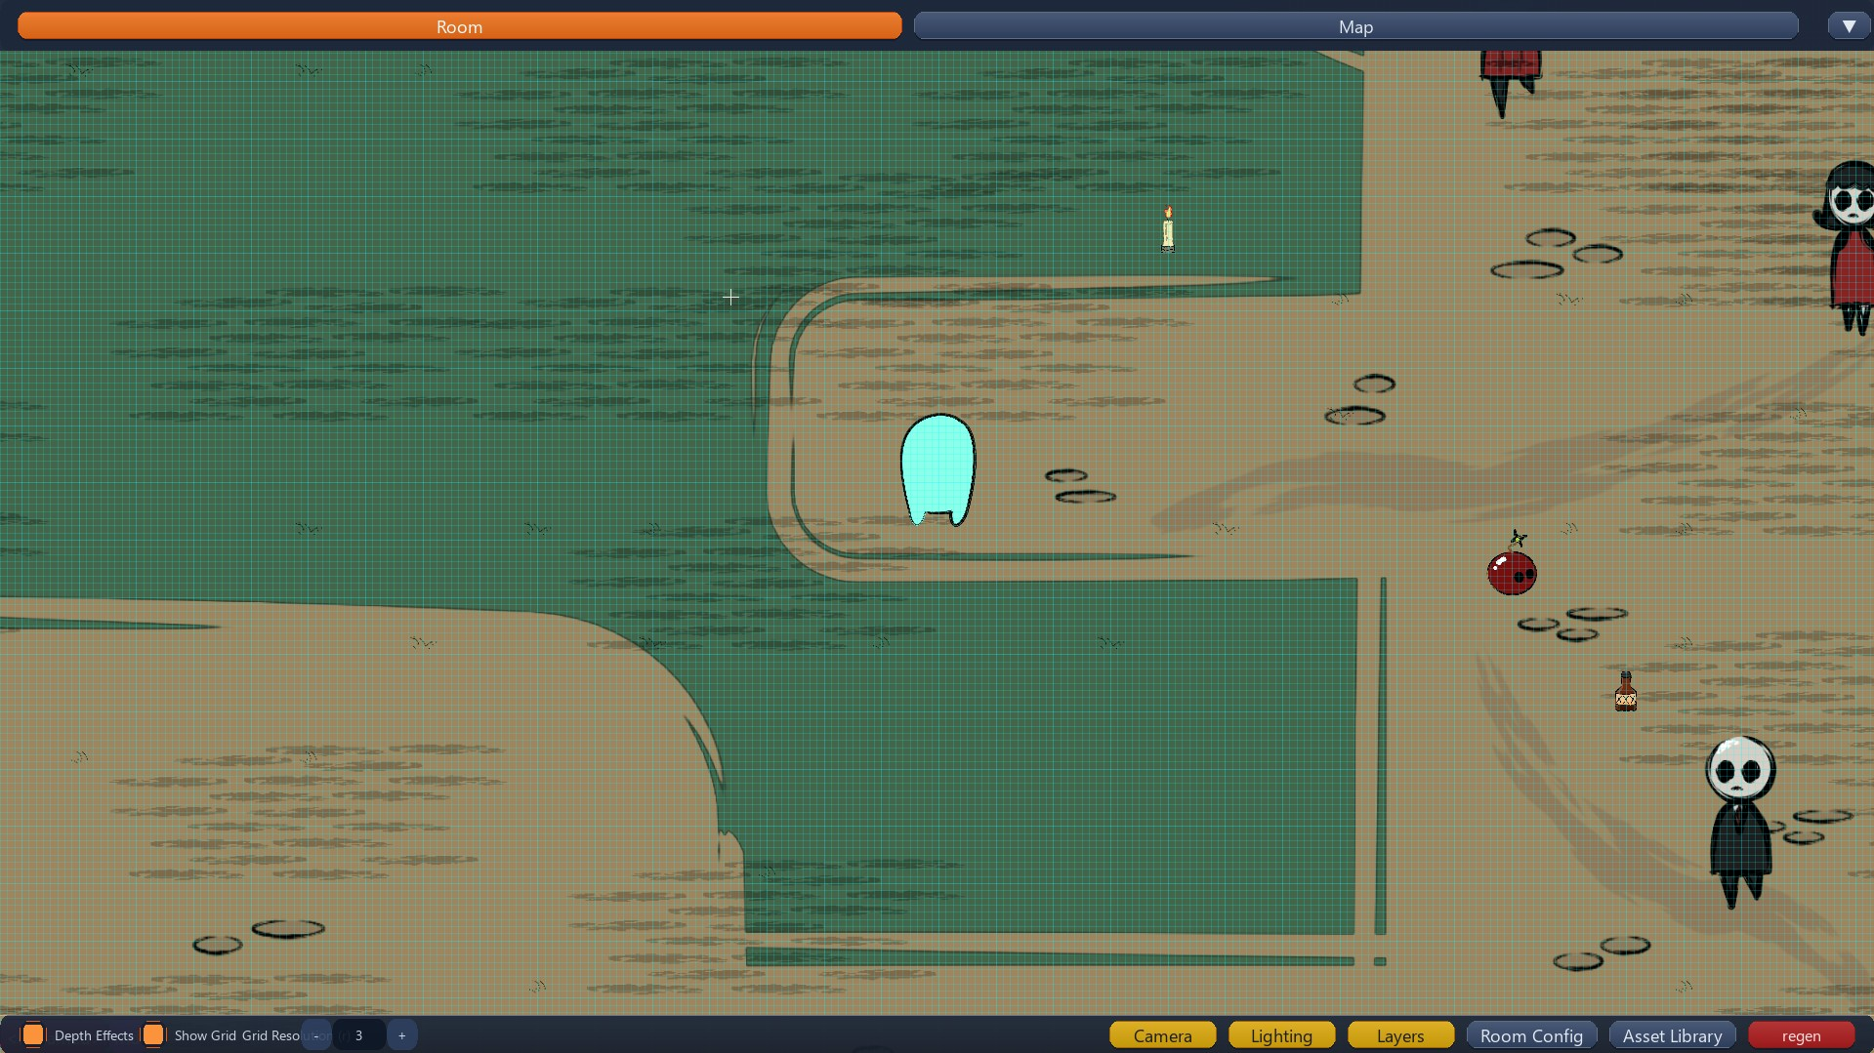
The main workspace layers the world view with floating headers, quick buttons, and panels that drive most editing tasks.

Page grid overview

The page grid shows which overlays and dialogs are active so navigation stays predictable when several editors are open.

Header and footer bar
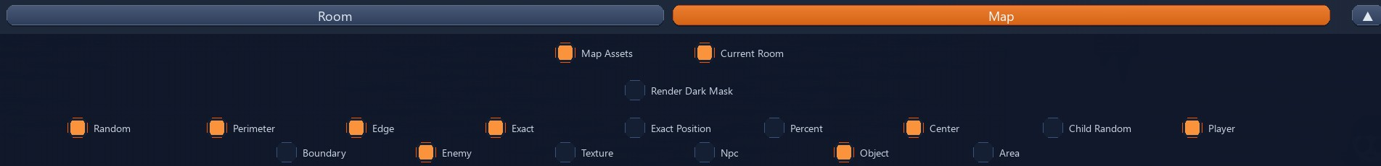
The header switches between room, map, and lighting modes. The footer shows notifications, quick tasks, and camera shortcuts.

Asset configuration panels

Asset library panel
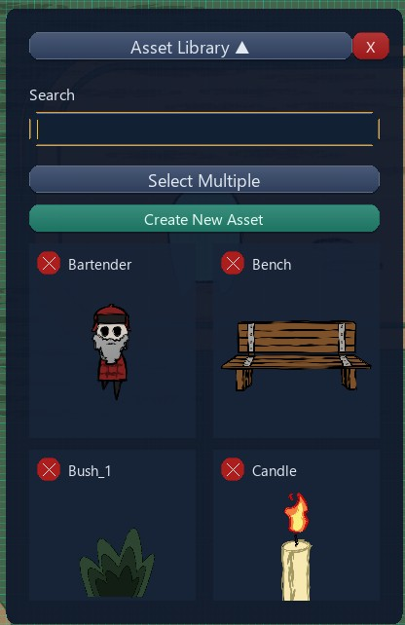
Browse manifest assets, drag them into the world, and open detailed editors from this floating catalog.

Asset info overview
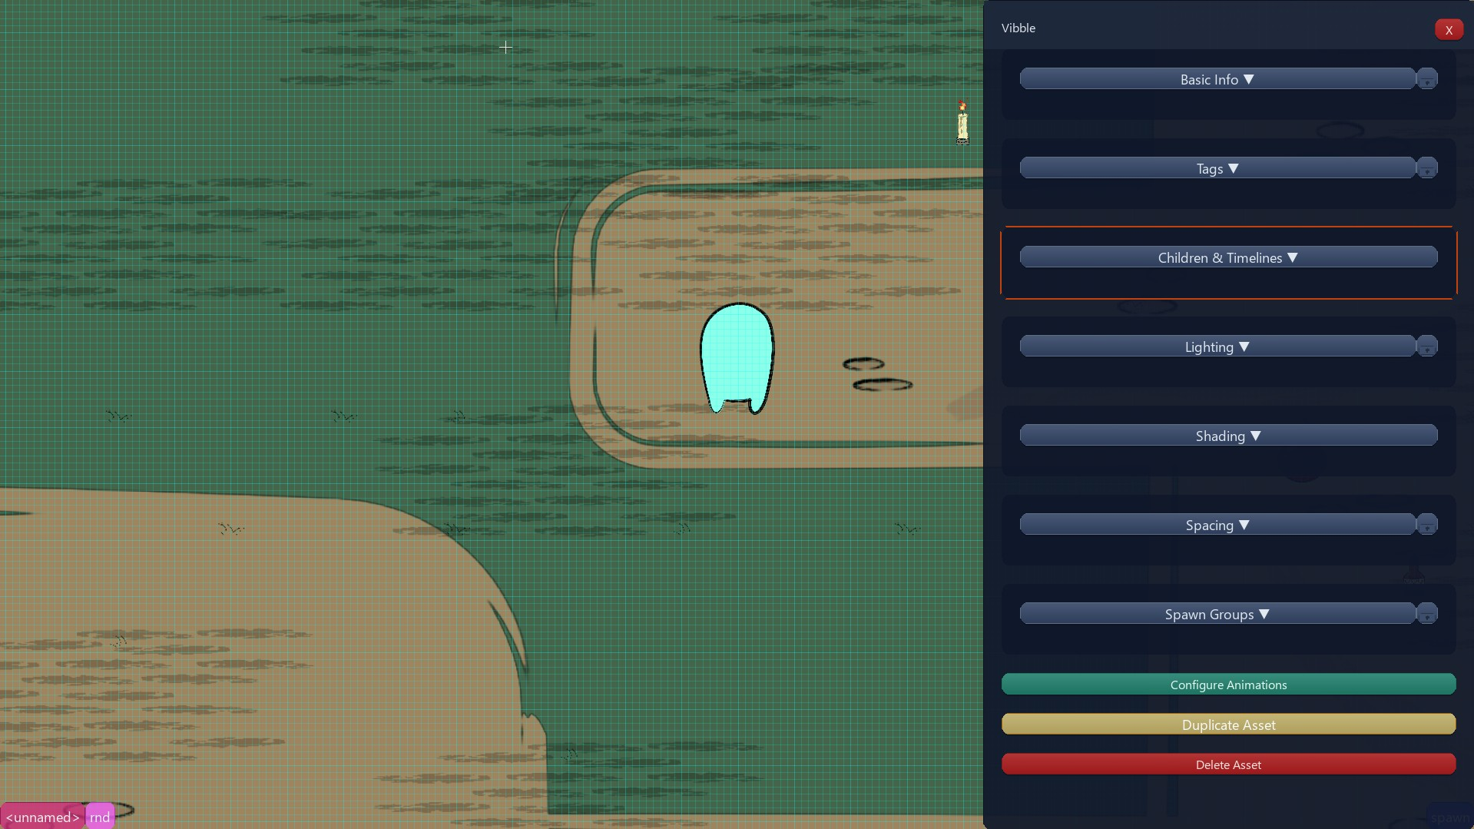
Asset info panels cover core properties, spawn groups, lighting hints, and animation hooks saved back to SRC and the manifest.

Basic info and tags
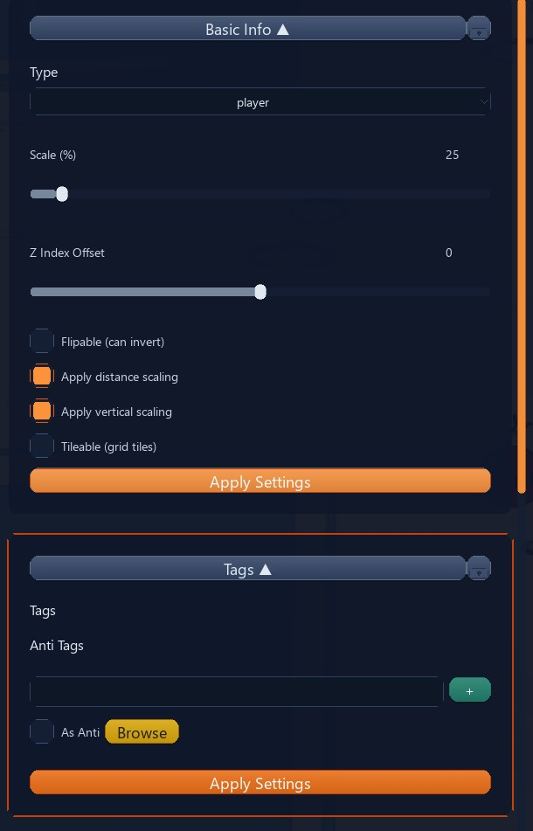
Basic info panels manage tags, start animations, scale variants, and movement settings for the selected asset.

Spacing panel
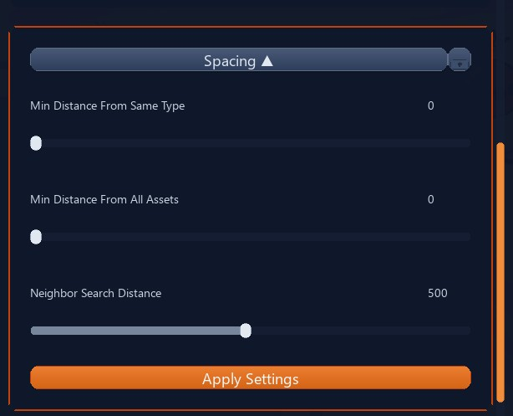
Spacing controls set minimum distance between instances and let you exclude assets from dense spawn groups.

Camera, lighting, and map overlay tools

Camera panel
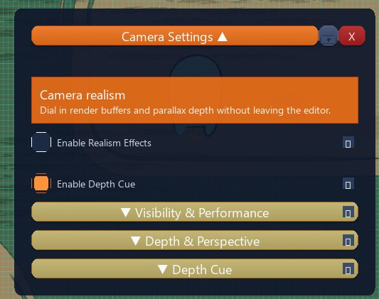
Adjust zoom, focus, and smoothing so the warped screen grid fits the play area while you debug.

Map light panel
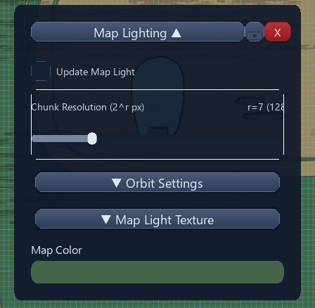
Edit light orbits, chunk resolutions, and color pairings here. Changes mark light_tool.py for a rebuild.

Map-mode lighting
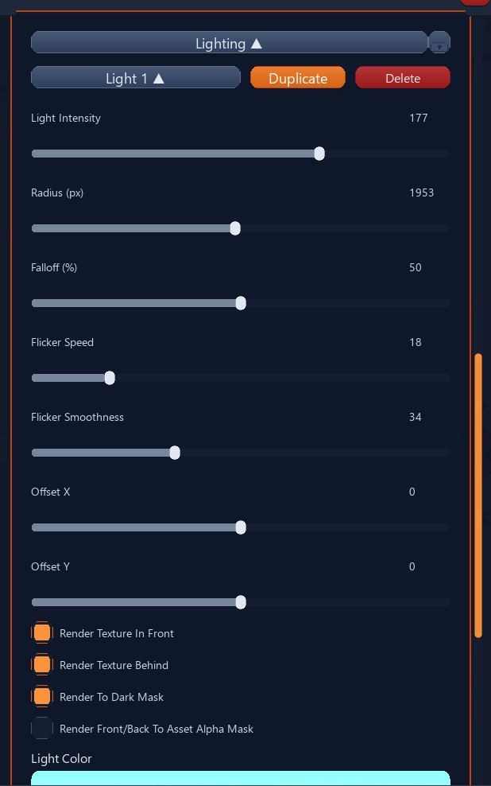
Map mode gives a top-down view of lighting previews, depth cues, and orbit handles.

Map-mode assets
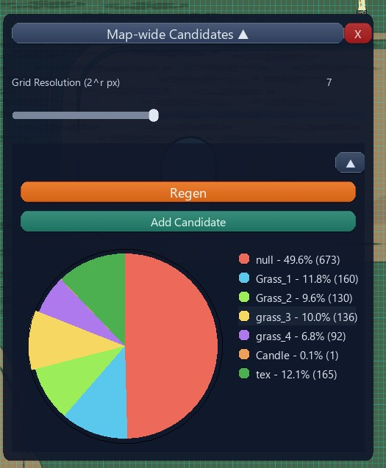
See spawn groups, trails, and boundary assets on the layered map canvas before committing changes.

Room and spawn editors

Room editor collapsed
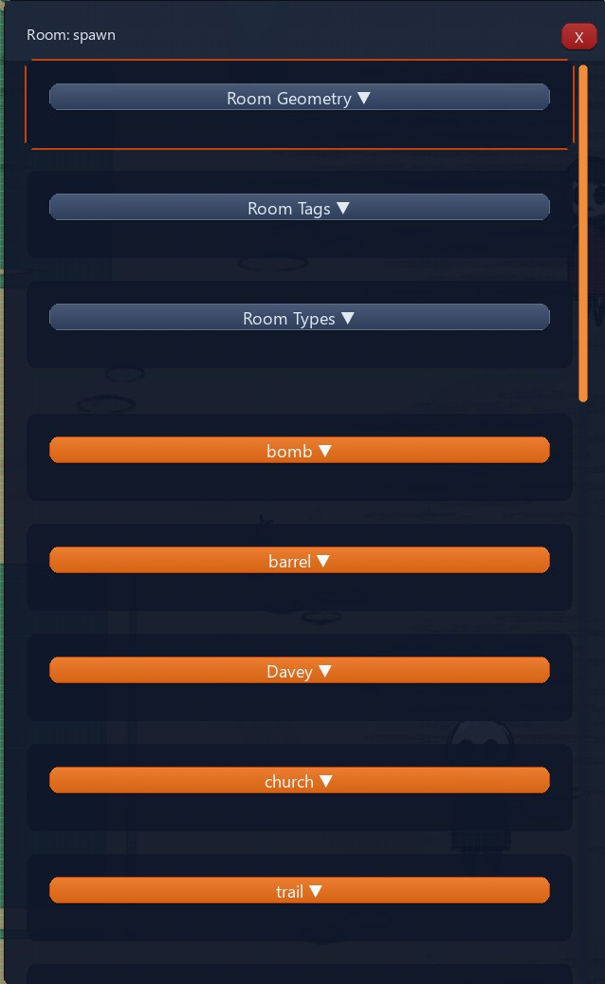
The room editor collapses when idle to keep the play view clear and expands with one click.

Room layers
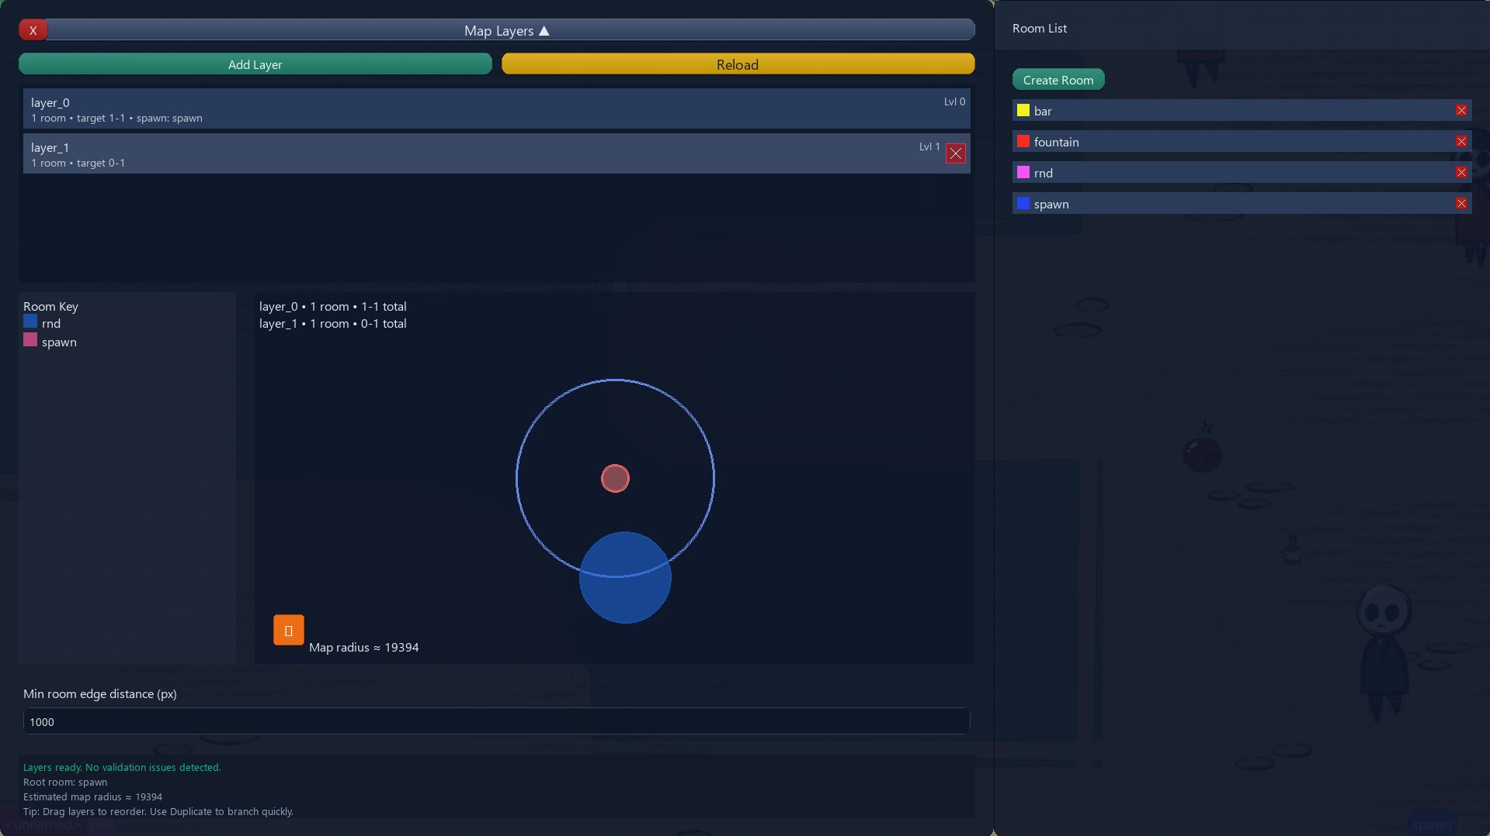
Layer controls set how many rooms appear per level, required children, and guide shapes for procedural layouts.

Room configuration expanded
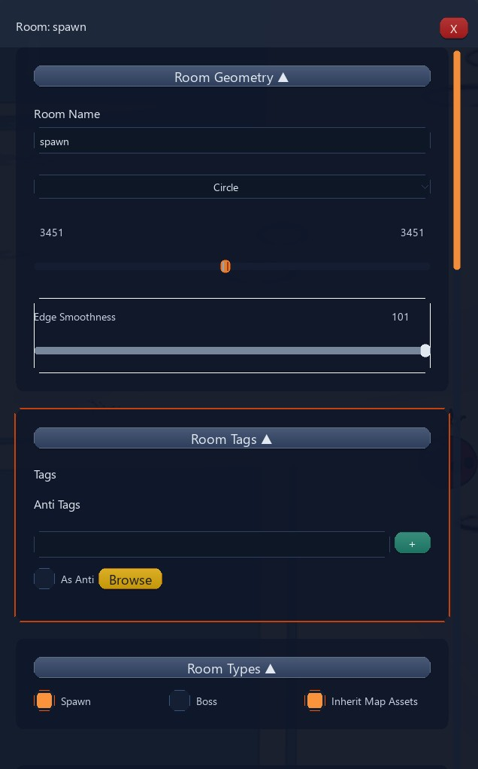
Room configuration shows spawn areas, area types, and metadata so manual edits stay in sync with the manifest.

Spawn group configuration
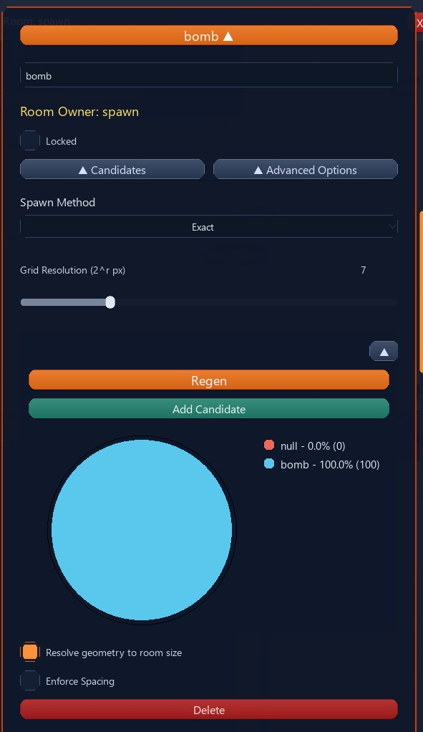
Spawn group settings combine spawners, weights, and grid resolution so you can test map-specific rules.

Animation and frame editors

Animation editor
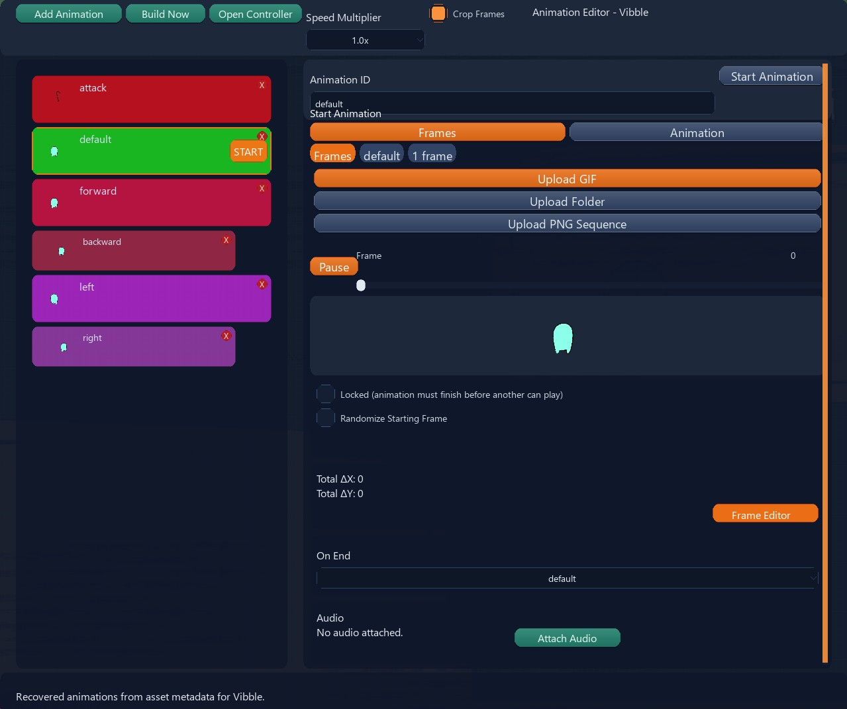
The animation editor mirrors the manifest, showing timelines, playback settings, and child attachments in a dockable window.

Movement panel
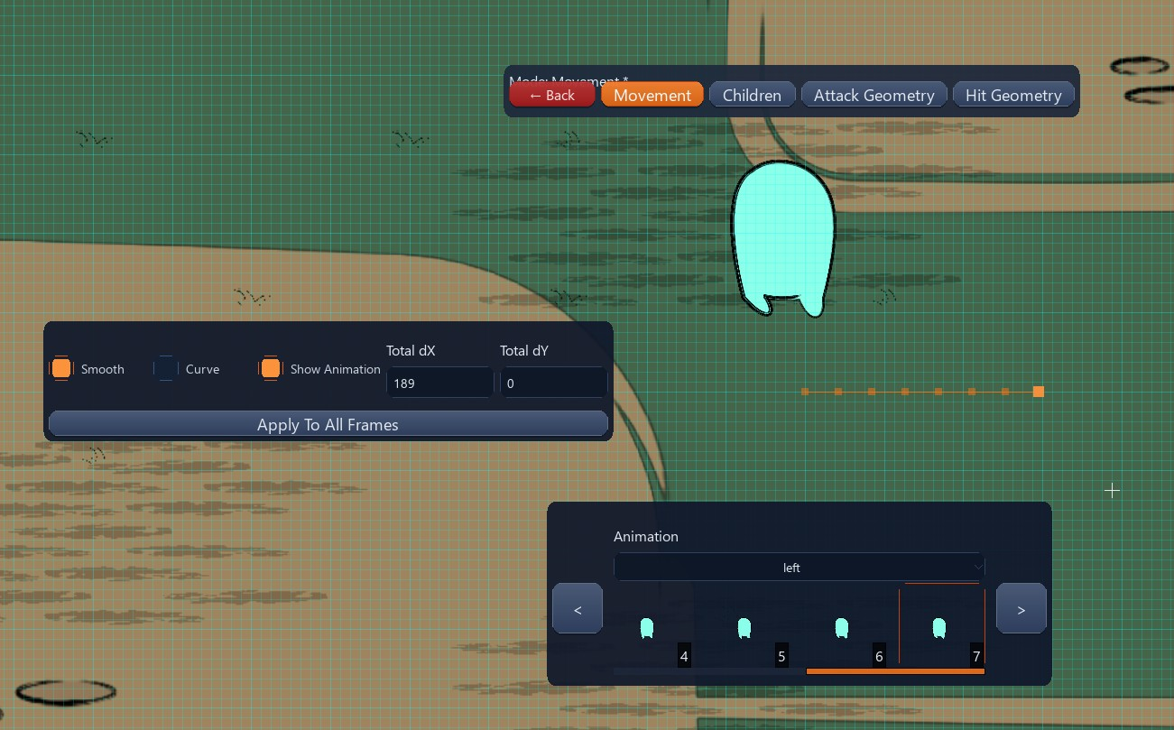
Movement panels reveal how motion translates to grid coordinates so controllers stay in sync with physics.

Hitbox panel
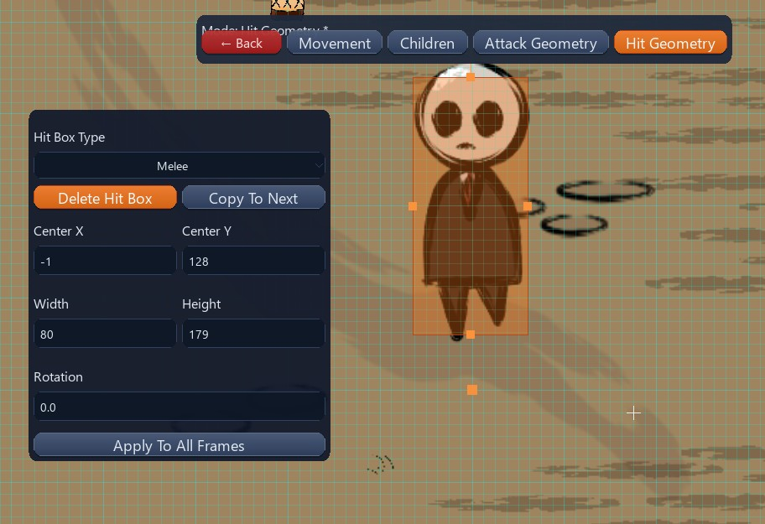
The hitbox panel shows collision bounds per frame to fine-tune interactions.

Attack geometry
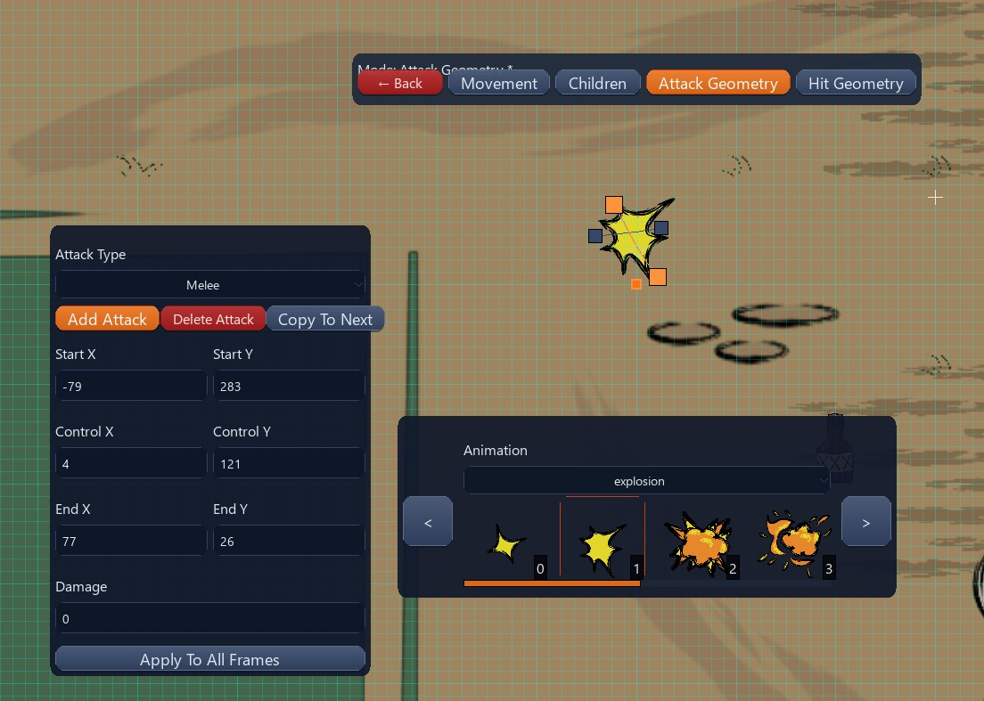
Attack geometry previews reach, damage zones, and timing for combat assets.

Children panel
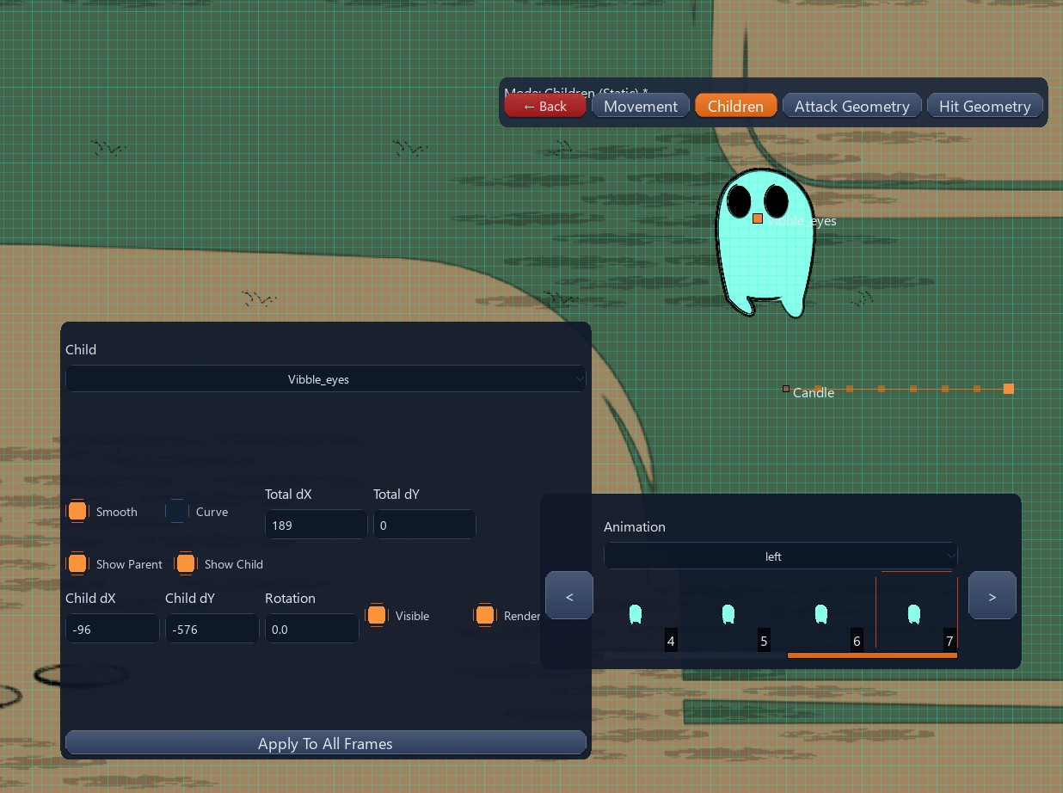
Child attachments and timelines stay readable here, along with parenting links and spawn behaviors.

Game Challenge
The main challenge we chose for our game was to create it from a custom engine. Major engines, such as Unity which we were taught for the class, are usually designed to be general purpose. We wanted to come up with an engine designed entirely for 2-dimensional games. With this, we could remove a lot of the bloat that takes up processing power within other game engines. Overall, this added a huge amount of work to the game. Not only did we have to think of designing the game, we also needed to design an engine from the ground up. Some of the biggest challenges when creating this were issues with: The camera and depth system including parallax and realism, keeping geometry consistent across the map grid, keeping JSON data, in-game assets, and editor state in sync during runtime, handling legacy data as features were added, as well as data and class ownership hierarchy. Throughout the course of making the engine, the overall design was changed many times to try and increase overall performance as well as simplify the original design.
The other challenge we wanted to try and tackle during this project was getting combat working. While we have working assets with their own animations, we didn't have a great way for players to attack enemies at the start. When working with Unity, you can easily call an object's collides function to then handle all of the details of attacking. For our engine, this is something we had to design from the ground up. Our way of dealing with this was to create child animations that an asset has ownership over. When an asset attacks another asset, we could then use this child to calculate if the animation overlaps with the other entity, if it does we could then apply the attacking logic on the asset. This gave us tons of trouble within the final few weeks of the project.
Along with these challenges we decided to tackle, we wanted to have a few quality of life features to help us in our development cycle. We can call these extra challenges as well that we worked on. The first one was an integrated room editor built directly into the engine. Within this room editor, the user can select rooms, view the bounds of rooms, place and drag spawn group configurations, and lastly configure asset animations. The second feature that was added was procedurally generated rooms. This works through taking data from JSON objects to randomly configure and regenerate rooms instead of having to hand-edit data. The last feature that we added was a UI panel for adjusting camera settings. Within this UI, the user can change realism settings, zoom settings to focus on key points, and depth cue controls.

Gameplay / Game Information
The genre of the game is roguelite. Roguelikes, the overarching genre, is a style of role-playing game where generally the main character must battle through dungeons to the end. The world is seen from a bird's eye view moving through a grid-based movement system and plays in a turn based style. If the player dies then the character is permanently dead. Roguelites are a sub-genre, characterized by having a procedurally generated world, persistent upgrades, and semi-permanent death. In some cases the death can restart the player's progress to zero and in other cases it only resets a player's gear and abilities. Some examples include D&D, Hades and Hades 2, slay the spire, and Spelunky.

Evaluation
Evaluation focuses on how well the custom engine and its runtime pipelines support the roguelite experience outlined above. We keep an eye on manifest-driven loading, procedural room construction, combat child animations, and render/camera stability so each subsystem can be stress-tested before it reaches players.

Member Responsibilities
Team members align around manifest maintenance, asset tooling, runtime flow, and the Dev Mode editors. Some engineers keep the manifest/SRC assets in sync, others tune the asset cache, light tool, and texture pipelines, while the rest focus on the grid, camera, and controller logic that powers gameplay and the editor panels that expose spawn, room, and animation data.

Conclusion
Departed Affairs & Co pairs a crafted 2D engine with procedural roguelite gameplay and a robust toolkit so the overworld hub, cemetery picker, and underworld missions feel cohesive; the overview above ties those narrative elements to the technical underpinnings that keep the experience playable, extendable, and ready for future polish.

